البيت المسكون

لـفرجينيا وولف

استيقظت ستجد بابًا موصدًا. من غرفة إلى غرفة تنقلا، متشابكا الأيدي، يرفعان هذا و يفتحان هذا، ليتأكدا ...زوجين شبحين.

قالت هى "تركناه هنا". و أضاف هو، "أه، لكن هنا أيضًا!" تمتمت، "أنه في الطابق العلوي". همس هو، "و في الحديقة أيضًا". قالا، "بهدوء، و إلا أيقظناهم".

أه، لا. لكن لم يكن أنتما من أيقظنا. أتوقع قائلة، "إنهما يبحثان عنه؛ لذلك يسحبان الستائر"، ثم أتابع قراءة صفحة أو اثنتين. سيكون المرء على يقين "أنهما قد وجداه آنذاك"، أضع قلم الرصاص على حافة الكتاب. و لاحقًا أتعب من القراءة، للمرء أن يتوقف و يتفحص بنفسه ليرى أن المنزل كله خالٍ، و الأبواب غير موصدة، فقط صوت هديل حمام الغابة متناغمًا مع طنين آلة الدرس القادم من المزرعة. "ما الي أتيت من أجله هنا؟ ما الذي أريد أيجاده؟" يداي كانت فارغتان. "إذن ربما يكون في الطابق العلوي ؟" كانت التفاحات في العلية. و كذلك نزلت مجددًا للأسفل، الحديقة كما كات دائمًا، فقط انزلق الكتاب على العشب.

لكنهما وجدا ما يبحثان عنه في حجرة المعيشة. لا يمكن أبدًا لاحد أن يراهم. The windowpanes reﬂected apples, reﬂected roses; all the leaves were green in the glass. If they moved in the drawing room, the apple only turned its yellow side. Yet, the moment after, if the door was opened, spread about the ﬂoor, hung upon the walls, pendant from the ceiling—what? يداي كانت فارغتان. The shadow of a thrush crossed the carpet; from the deepest wells of si- lence the wood pigeon drew its bubble of sound. “Safe, safe, safe” the pulse of the house beat softly. “The treasure buried; the room...” the pulse stopped short. Oh, was that the buried treasure? A moment later the light had faded. Out in the garden then? But the trees spun darkness for a wandering beam of sun. So ﬁne, so rare, coolly sunk beneath the surface the beam I sought always burned behind the glass. Death was the glass; death was between us, coming to the woman ﬁrst, hundreds of years ago, leaving the house, sealing all the windows; the rooms were darkened. He left it, left her, went North, went East, saw the stars turned in the Southern sky; sought the house, found it dropped beneath the Downs. “Safe, safe, safe,” the pulse of the house beat gladly. “The Treasure yours.”

The wind roars up the avenue. Trees stoop and bend this way and

that. Moonbeams splash and spill wildly in the rain. But the beam of the lamp falls straight from the window. The candle burns



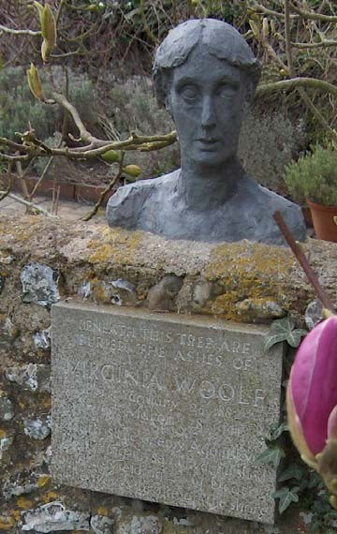

*Beneath this tree are buried the ashes of Virginia Woolf...*

Photo by Oliver Mallinson Lewis from Oxford, UK, and reworked by the Bilderwerkstatt. Taken from Wikimedia Commons

and licensed under the Creative Commons Attribution ShareAlike 2.0 license. <http://tinyurl.com/4t2wk2>

Virginia Woolf A Haunted House • 2

stiﬀ and still. Wandering through the house, opening the windows, whispering not to wake us, the ghostly couple seek their joy.

“Here we slept,” she says. And he adds, “Kisses without number.” “Waking in the morning—” “Silver between the trees—” “Up- stairs—” “In the garden—” “When summer came—” “In winter snowtime—” The doors go shutting far in the distance, gently knocking like the pulse of a heart.

Nearer they come, cease at the doorway. The wind falls, the rain slides silver down the glass. Our eyes darken, we hear no steps be- side us; we see no lady spread her ghostly cloak. His hands shield the lantern. “Look,” he breathes. “Sound asleep. Love upon their lips.”

Stooping, holding their silver lamp above us, long they look and deeply. Long they pause. The wind drives straightly; the ﬂame stoops slightly. Wild beams of moonlight cross both ﬂoor and wall, and, meeting, stain the faces bent; the faces pondering; the faces that search the sleepers and seek their hidden joy.

“Safe, safe, safe,” the heart of the house beats proudly. “Long years—” he sighs. “Again you found me.” “Here,” she murmurs, “sleeping; in the garden reading; laughing, rolling apples in the loft. Here we left our treasure—” Stooping, their light lifts the lids upon my eyes. “Safe! safe! safe!” the pulse of the house beats wildly. Wak- ing, I cry “Oh, is this your buried treasure? The light in the heart.”

Virginia Woolf

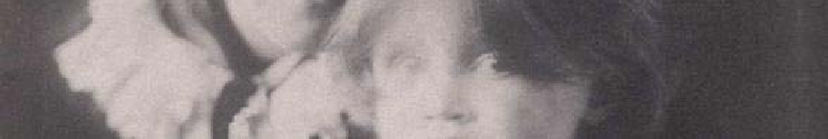

Adapted from Wikipedia: (Adeline) Virginia Woolf (née Stephen; 25 January 1882 – 28 March 1941) was an English novelist and essayist, regarded as one of the foremost modernist literary ﬁgures of the twentieth century.

During the interwar period, Woolf was a signiﬁcant ﬁgure in London literary society and a member of the Bloomsbury Group. Her most famous works include the novels *Mrs Dalloway* (1925), *To the Lighthouse* (1927) and *Orlando* (1928), and the book-length essay *A Room of One's Own* (1929).

On March 28, 1941, after having a nervous breakdown, Woolf drowned herself by weighing her pockets with stones and walking into the River Ouse near her home. Her body was not found until 18 April. Her husband buried her cremated remains under a tree in the garden of their house in Rodmell, Sussex.

The picture of her eyes is cropped from a photo taken when she was a child on her mother’s lap in 1884. Provided courtesy of Wikimedia Commons.

*This story was originally published*

*in* Monday or Tuesday *by Harcourt, Brace and Company in 1921. It is in the public domain.*